ASSIGNMENT No: 01
Title: Import Data from different Sources such as (Excel, Sql Server, Oracle etc.) and load in targeted system.
Problem Statement: Import Data from different Sources such as (Excel, Sql Server, Oracle etc.) and load in targeted system.
Prerequisite:
Basics of Python
Software Requirements: Power BI Tool
Hardware Requirements:
PIV, 2GB RAM, 500 GB HDD
Learning Objectives:
Learn to import data from different sources such as(Excel, Sql Server, Oracle etc.) and load in targeted system.
Outcomes:
After completion of this assignment students are able to understand how to import data from different sources such as(Excel, Sql Server, Oracle etc.) and load in targeted system.
Theory:
What is Legacy Data?
Legacy data, according to Business Dictionary, is "information maintained in an old or outof-date format or computer system that is consequently challenging to access or handle."
Sources of Legacy Data
Where does legacy data come from? Virtually everywhere. Figure 1 indicates that there are many sources from which you may obtain legacy data. This includes existing databases, often relational, although non-RDBs such as hierarchical, network, object, XML, object/relational databases, and NoSQL databases. Files, such as XML documents or "flat files"ù such as configuration files and comma-delimited text files, are also common sources of legacy data. Software, including legacy applications that have been wrapped ( perhaps via CORBA) and legacy services such as web services or CICS transactions, can also provide

access to existing information. The point to be made is that there is often far more to gaining access to legacy data than simply writing an SQL query against an existing relational database.
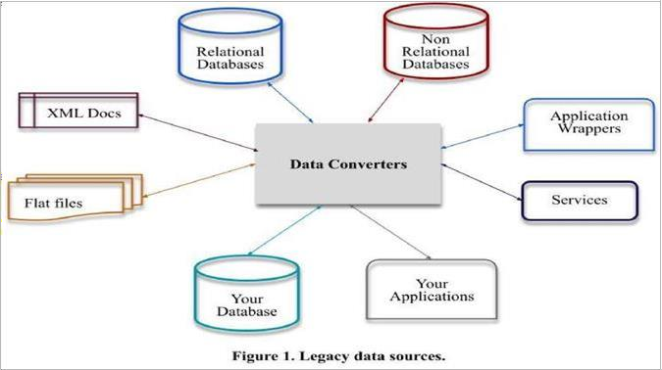

Importing Excel Data
- Launch Power BI Desktop.

- From the Home ribbon, select Get Data. Excel is one of the Most Common data connections, so you can select it directly from the Get Data menu.

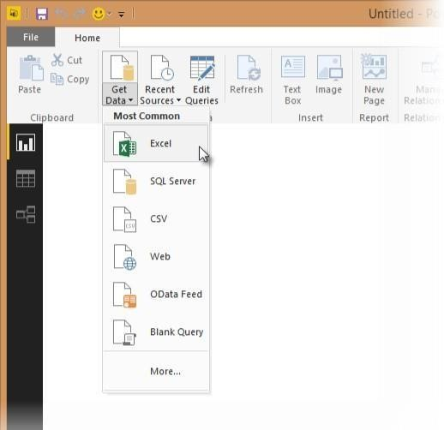

- If you select the Get Data button directly, you can also select FIle > Excel and select Connect.

- In the Open File dialog box, select the Products.xlsx file.

- In the Navigator pane, select the Products table and then select Edit.

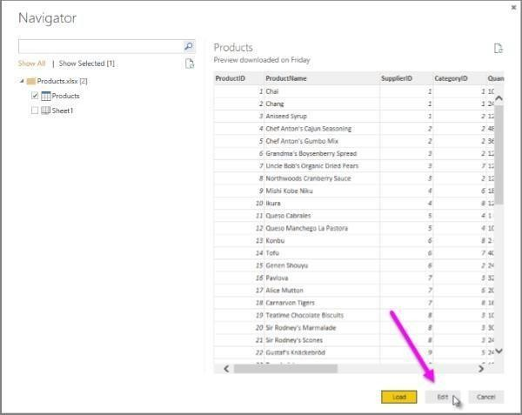

Importing Data from OData Feed
In this task, you'll bring in order data. This step represents connecting to a sales system. You import data into Power BI Desktop from the sample Northwind OData feed at the following URL, which you can copy (and then paste) in the steps below: http://services.odata.org/V3/Northwind/Northwind.svc/
Connect to an OData feed:
- From the Home ribbon tab in Query Editor, select Get Data.

- Browse to the OData Feed data source.

- In the OData Feed dialog box, paste the URL for the Northwind OData feed.

- Select OK.

- In the Navigator pane, select the Orders table, and then select Edit.

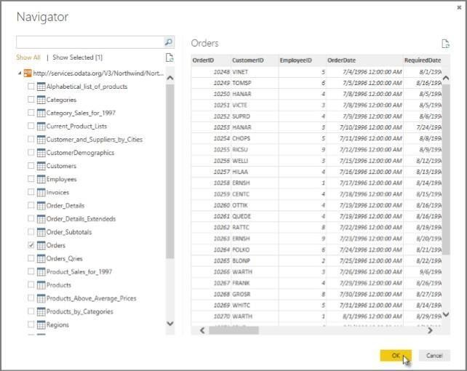

Conclusion: - This way, Implemented a program for inverted files.

